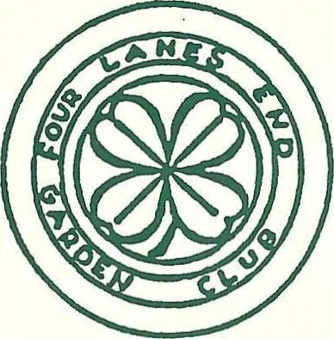
FOUR LANES END GARDEN CLUB
P.O. BOX 434 LANGHORNE, PA 19047
Floral Certification Application Form
for the 2027-2028 school year
Name Date of Birth

Address

Email

Telephone Social Security Number

High School/College Enrollment/History/Major

Background and Experience *(include with personal letter)
- Current Industry Role: Are you currently employed in a flower shop, farm, or event design business?
- Prior Training: List any past hands-on workshops, horticulture classes, or self-taught experience.
- Certification Goal: Which specific credential are you pursuing (e.g., State Floral Association Certification, Certified Floral Designer (CFD), or Texas Master Florist?)
Goals and Motivation *(include with personal letter)
- Career Vision: What are your short-term and long-term goals in the floral industry?
- Why Certification Matters: How will earning this specific floral designation impact your professional path and daily work?

Please include with application:
- Personal Letter by applicant including goals, background and personal commitment * (see above)
- Two Letters of Reference from Faculty (preferred - if not available, personal letter/reference)

Application due no later than April 30, 2027
Mail to: Christina Foster 202 Dilworth Lane, Langhorne, PA 19047

